***Experiment 7 Output***

SQL queries were **optimized** for large-scale data warehouse applications using **indexing, partitioning, and query tuning techniques**.

***Queries and indexing***

***Selecting Tuples from tables***

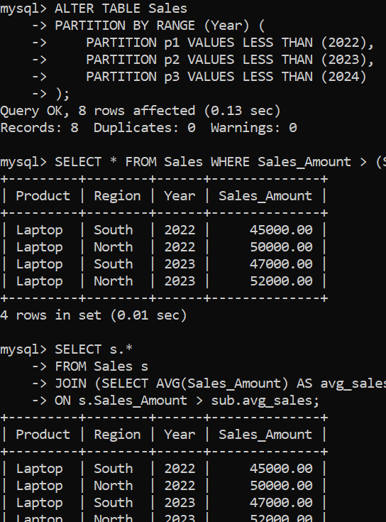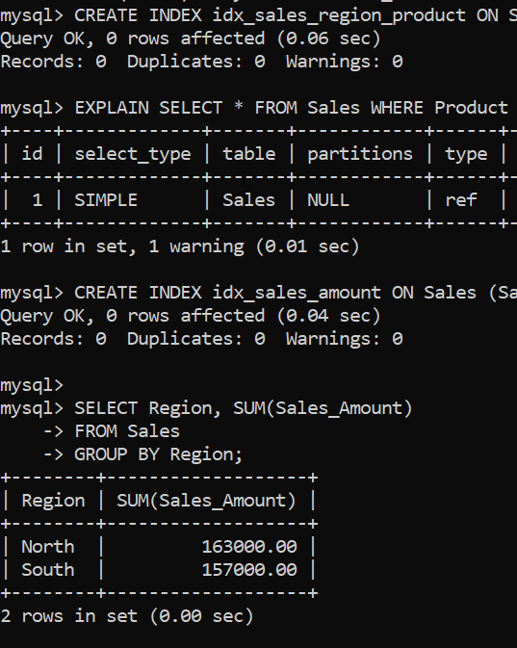

***Creating Tables***

***Fig 2: Selecting using conditions instead of \****

***Fig 1: Queries output after indexing***

***Extracting Data***

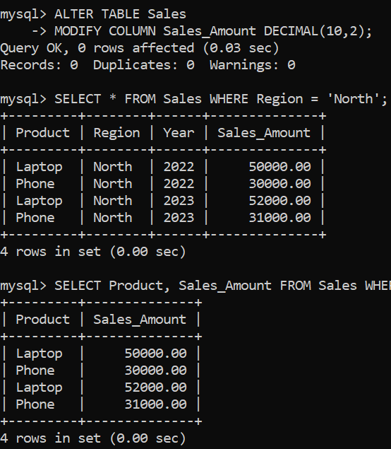

***Loading Data using Columns***

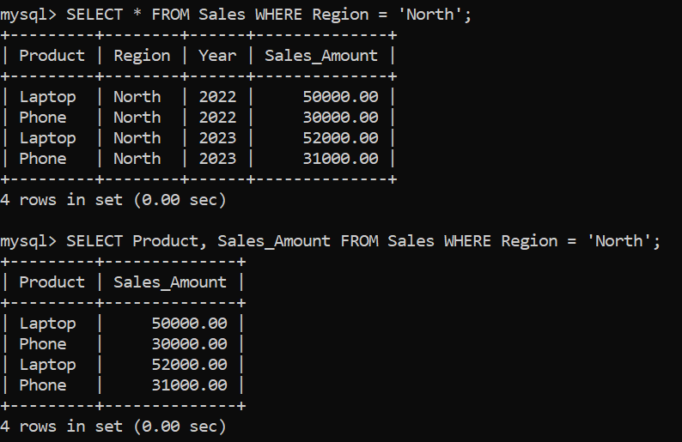

***Fig 3: Conditional Queries Output***

***Fig 4: Columns Queries***